CORUNNA MINOR ATHLETIC ASSOCIATION
CORUNNA, ONTARIO N0N 1G0
“Home of the Giants”
www.corunnaminorbaseball.com

Corunna Minor Athletic Association
Corunna, ON N0N 1G0

Date: ______________________

Please conduct a Vulnerable Sector Screening Check for our applicant:

APPLICANT/VOLUNTEER NAME: ________________________________________

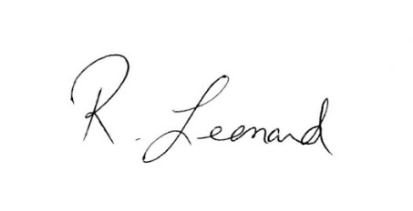
The above mentioned applicant is a volunteer with our organization as a coach, trainer, team official or executive member who will be working with children and vulnerable persons. It is the Association’s standard policy that our volunteers obtain a Criminal Record Check – Vulnerable Sector Verification in order to work with our members

Signature of Organization Representative:

COST - VOLUNTEERS – NO CHARGE

ID REQUIRED - 2 Pieces – One photo and one non-photo/or/photo accepted.
- Driver's License, BYID Card, Canadian or Foreign Passport, Canadian Citizenship Card, Possession and Acquisition License (or PAL Card), Permanent Residency Card, Certificate of Indian Status, Birth Certificate, Baptismal Certificate, Hunting License, Outdoors Card, Immigration Papers, Nexus.

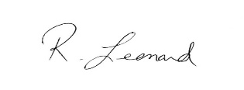

Rick Leonard, President
Corunna Minor Athletic Association
Cell (519) 328-8794
Email: president@corunnaminorbaseball.com

